The core operations known as CRUD (Create, Read, Update, Delete) help you operate with data stored in MongoDB.

I am taking **Hospital Management as** real life example for CRUD operations in **MongoDB**

CRUD application with MongoDB for hospital administration:   
  
Gatherings:  
   
**Patients**: Contains data on the patient, including name, ID, birthdate, medical history, allergies, contact information, and insurance details.

**Physicians**: Maintains a record of physician information, including name, ID, specialization, credentials, availability for appointments, and contact data.

**Appointments**: Record information about the patient and the physician, the date and time of the visit, the kind of appointment (consultation, examination, surgery), and any notes.

**medicine**: Keeps track of prescriptions and medical information, such as patient identification number, name, dose, frequency, and length of use.

**Admissions**: Maintains track of patient information, room number, diagnosis, date of admission, and date of release from the hospital.

CRUD Operations:

Create:

**insert One**:

Open a new patient account:

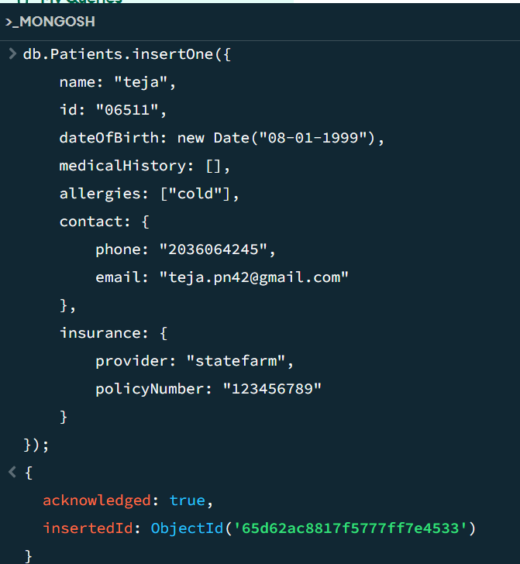

**insert Many**:

Add multiple patients:

Multiple documents can be inserted into a collection in a single operation using MongoDB's insertMany() function.

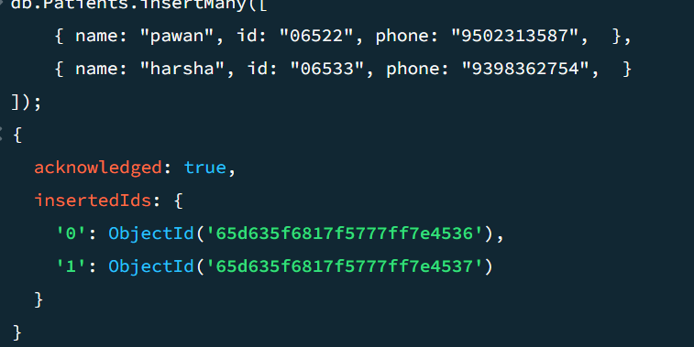

Each document has three fields and is a representation of a patient record:

**name**: The name of the patient

**id**: A string that uniquely identifies the patient

**phone:** The phone number of the patient

**Read:**

**find:** A key tool in MongoDB for obtaining documents from a collection according to predetermined criteria is the find () function. Efficient and safe document retrieval requires an understanding of its syntax, query operators, and performance factors.

Search for patients with their name

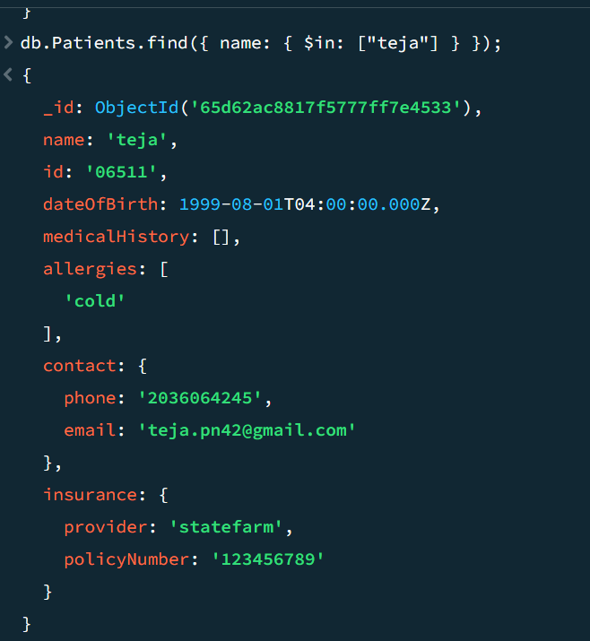

Find many:

The code below is to find all documents where the insurance provider is "statefarm".

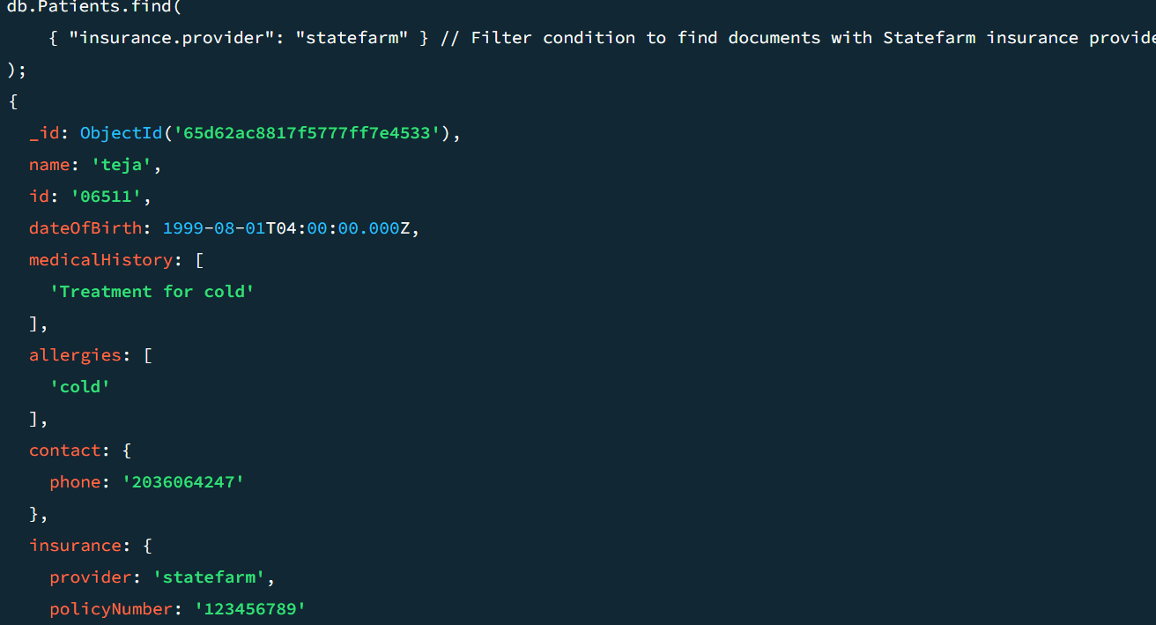

Update:

**update One**: Revise the patient's contact details:

In MongoDB, the update One() function is used to change a single document that satisfies a certain filter condition within a collection.

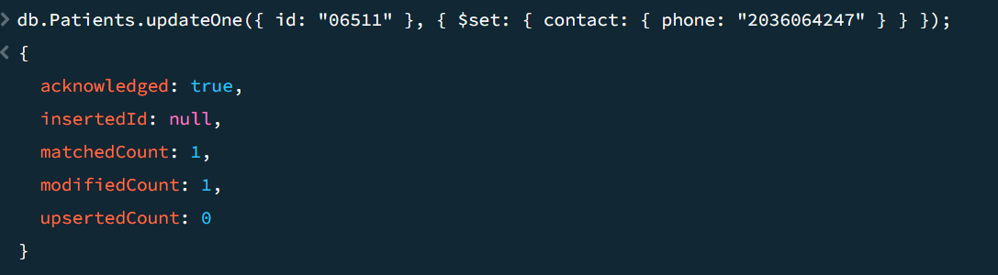

In the above code we have updated the patient's mobile number through the patients Id

**Update many**: In MongoDB, the updateMany() function is used to change several documents in a collection that satisfy a certain filter criteria.

A vast number of documents may be impacted by updateMany(), depending on the filter criteria. Because of this, it is crucial to think about how it will affect performance, particularly for big collections.

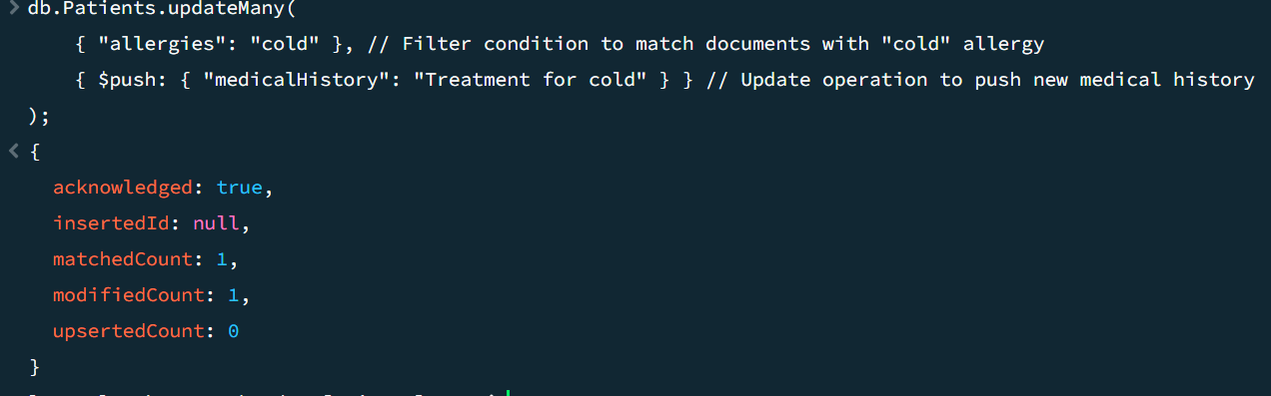In the above code we have updated the medical history.

Delete one:

In MongoDB, deleteOne() is a helpful function for eliminating certain documents according to predefined standards. It is imperative to use it sparingly, considering security and performance consequences.

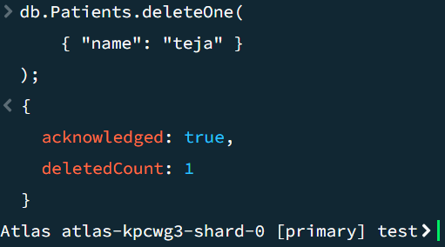

The above code will delete the document where the name field is "teja".

Delete all:

The delete Many () function in MongoDB is used to remove many documents that satisfy a given criteria. In MongoDB, the delete Many () function is an effective way to eliminate many documents from a collection according to predefined standards. It's important to be cautious and aware of the consequences, particularly if you are deleting a lot of papers or all of them.

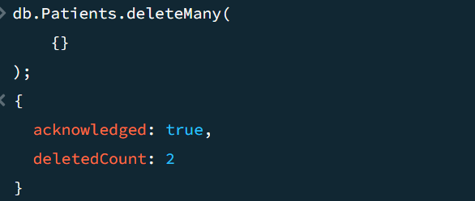

After executing the above code ,All of the documents in the Patients collection will be removed.